Bug Report

Description:

In the registration form Twitter button does not work

Steps to reproduce:

1. Go to [www.sportklub.rs](http://www.sportklub.rs)
2. Click on the Registration button
3. Click on the Twitter button

Test Data:

/

Expected Result:

Log in page from Twitter

Actual Result:

Error page opens

Time Stamp:

6/11/2019, Wednesday at 11.14 a.m.

Screenshot:

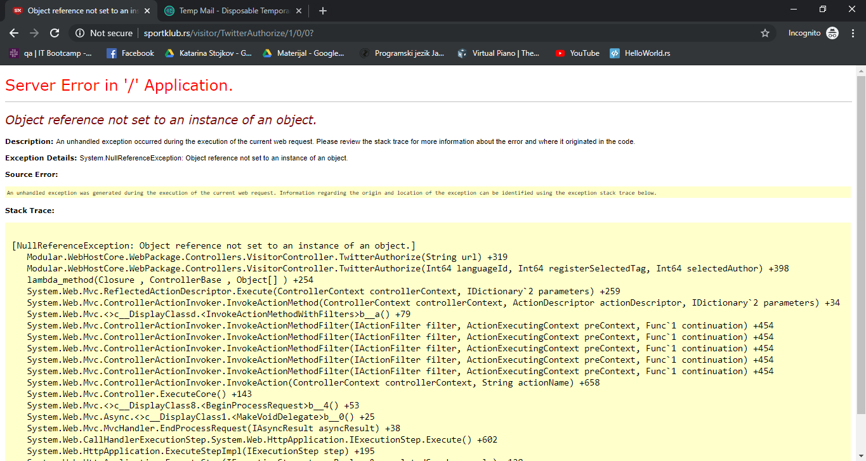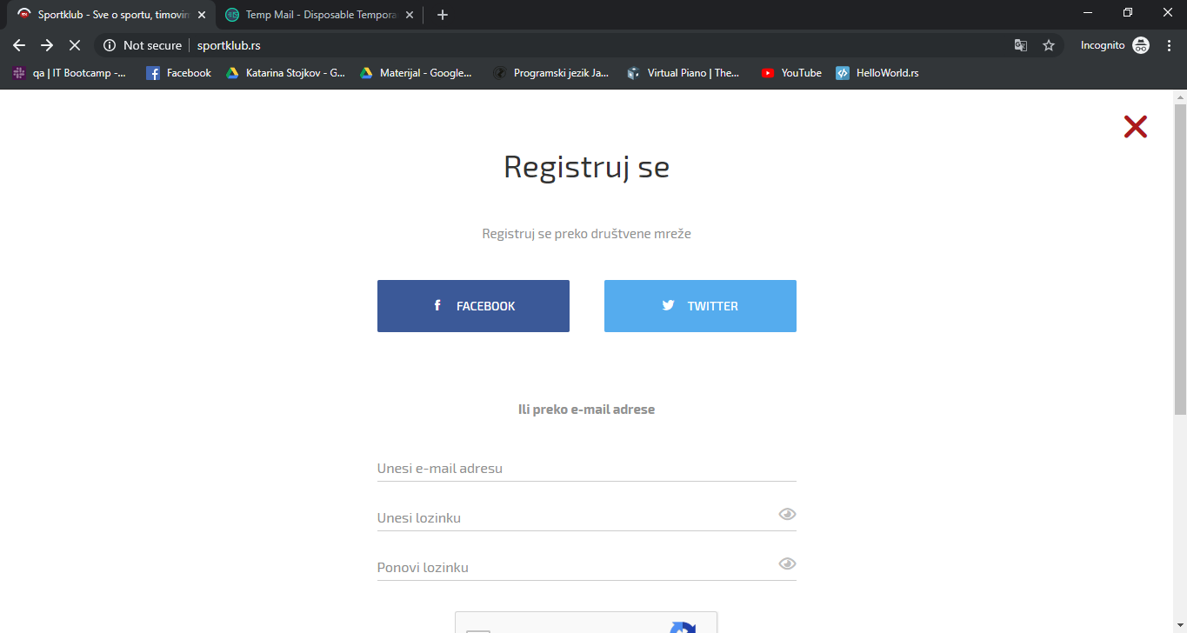

Environment:

Google Chrome Version 78.0.3904.87; Android Version 9

Severity:

Medium

Priority:

Medium